**Printf Scanf Assignment**

Q1. WAP with

1a. function readdisplay() to read the following data types only one at a time at run time and to display.

1. char type

2. integer type

3. char array of maximum 80 characters

4. short type

5. float type

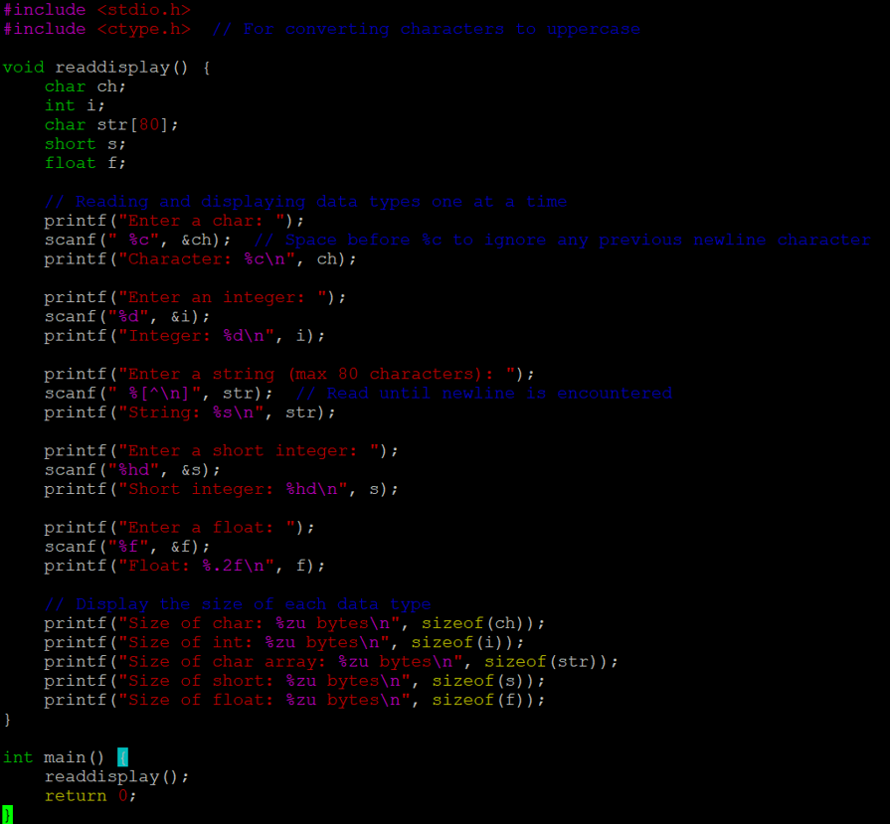

1b. Function readdisplay2()

1c. Display the char array content in uppercase:

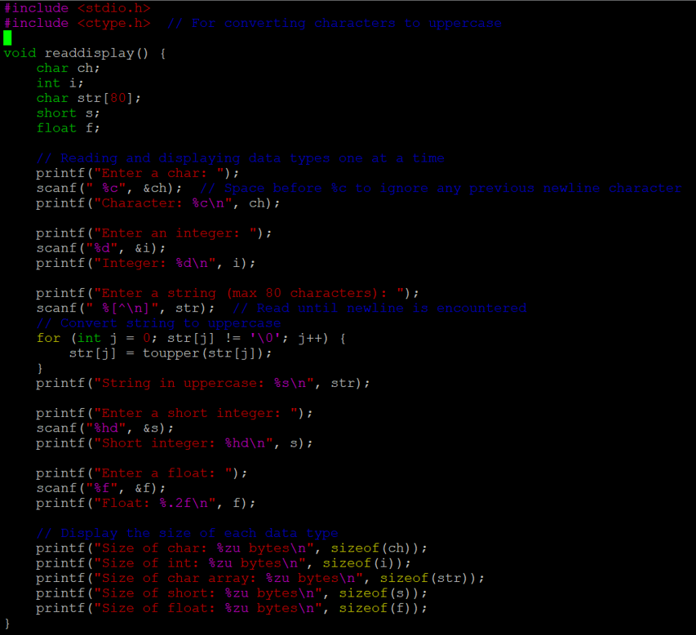

**1d. Display the size of each data type**

This has already been added to both readdisplay() and readdisplay2(). The code uses sizeof() to print the size of each data type.

Q2: Running the provided code snippet and fixing it

**Incorrect Code:**

#include<stdio.h>

int main()

{

unsigned long int ul = 200333333334340;

printf("value is:%d\n", ul); // Wrong format specifier

return 0;

}

